SERVICE REQUEST FORM:
Boronia Hub
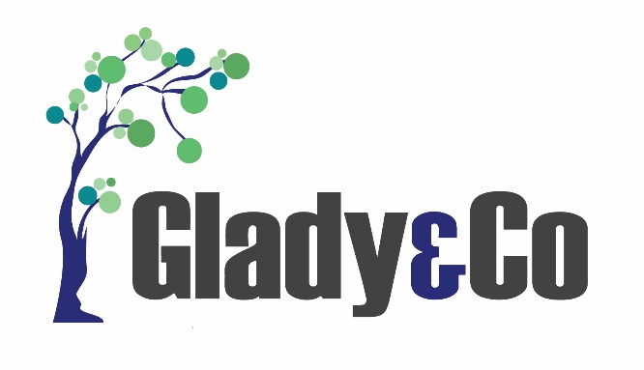

Please complete form online by clicking in light GREY boxes
Box will automatically extend with large amount of text.
REFERRER INFORMATION
Referrer Name |  | Click or tap here to enter text. |  |  | Date of Referral | Click or tap here to enter text.
Organisation |  | Click or tap here to enter text. |  |  | Phone | Click or tap here to enter text.
Role |  | Click or tap here to enter text. |  |  | Email | Click or tap here to enter text.
PARTICIPANT INFORMATION
First Name |  | Click or tap here to enter text. |  |  | Last Name | Click or tap here to enter text.
Preferred Name |  | Click or tap here to enter text. |  |  | Date of Birth | Click or tap here to enter text.
Gender |  | Click or tap here to enter text. |  |  | Preferred Pronouns | Click or tap here to enter text.
Address |  | Click or tap here to enter text.
Mobile |  | Click or tap here to enter text. |  |  | Phone | Click or tap here to enter text.
Email |  | Click or tap here to enter text. |  |  | Other | Click or tap here to enter text.
 | GUARDIAN / NOMINEE / TRUSTEE DETAILS (if applicable)
 | Name |  | Click or tap here to enter text. | Phone |  | Click or tap here to enter text.
 | Relationship |  | Click or tap here to enter text. | Email |  | Click or tap here to enter text.
 | DOES PARTICIPANT HAVE AN ADVOCATE? *
 | Name |  | Click or tap here to enter text. | Phone |  | Click or tap here to enter text.
 | Other Details |  | Click or tap here to enter text. | Email |  | Click or tap here to enter text.
 | SUPPORT COORDINATOR / RECOVERY COACH DETAILS (if different to referrer)
 | Name |  | Click or tap here to enter text. | Phone |  | Click or tap here to enter text.
 | Organisation |  | Click or tap here to enter text. | Email |  | Click or tap here to enter text.
 | PLAN MANAGER DETAILS
 | Name |  | Click or tap here to enter text. | Phone |  | Click or tap here to enter text.
 | Organisation |  | Click or tap here to enter text. | Email |  | Click or tap here to enter text.
PARTICIPANT NDIS INFORMATION
NDIS Number |  | Click or tap here to enter text.
Plan Start Date |  | Click or tap here to enter text. |  |  | Plan End Date | Click or tap here to enter text.

HUB GROUP DAY/S PREFERENCE (see program for daily activities)
How many weekdays would you like to attend the group program? |  |  |  | 1 |  | 2 | 3 |  | 4 | 5
Indicate preferred day/s for group program. See program online - Recovery Hubs - Glady and Co - Mental Health Support
MONDAY | TUESDAY | WEDNESDAY | THURSDAY |  | FRIDAY |  |  | SATURDAY

PARTICIPANT METAL HEALTH AND MEDICAL INFORMATION (more details in risk assessment)
PRIMARY Mental Health Diagnosis | Click or tap here to enter text.
Other Mental Health Diagnosis | Click or tap here to enter text.
Physical Health / Medical Needs | Click or tap here to enter text.
ADDITIONAL SUPPORTS AND SERVICES
Are you interested in receiving more information on additional supports provided by Glady & Co?
Support Coordination or Recovery Coaching |  | Yes | No
Support Work |  | Yes | No
INSPIRE Recovery Retreats |  | Yes | No
Emergency Accommodation |  | Yes | No
Prevention and Recovery Accommodation (Respite/Short or Medium Term) |  | Yes | No

What Next?
- Send completed forms and a copy of participants NDIS Plan to intake@gladyandco.com.au
- Our Hub team will contact you within 2-3 business days to arrange a walk through the Hub and answer any questions.

*What is an Advocate?
It is your right to request an Advocate. An Advocate is someone who speaks up for you if you cannot speak up for yourself. Please find the following links to some Advocacy Groups in Victoria.

https://www.vmiac.org.au/

https://www.imha.vic.gov.au/

https://www.legalaid.vic.gov.au/independent-mental-health-advocacy

